📌 DBMS Query Processing Cheat Sheet

1. Basic Operators
- Projection (π) → Keeps selected attributes (columns).
  - With duplicates removed: T(W) = V(R,A)
  - Without duplicates: T(W) = T(R)
  - SQL: SELECT DISTINCT ...
- Selection (σ) → Keeps selected tuples (rows).
  - Equality: T(W) = T(R) / V(R,A)
  - Inequality (≤, ≥, <, >): ≈ T(R)/2 (if uniform distribution)
- Cartesian Product (×) → Every tuple in R with every tuple in S.
  - T(R × S) = T(R) × T(S)
- Join (⋈) → Tuples from R and S that match on common attribute A.
  - Formula:
  - T(R ⋈ S) = (T(R) × T(S)) / max(V(R,A), V(S,A))
  - If no common attribute: reduces to Cartesian product.
- Set Operations (require same schema)
  - Union: R ∪ S → all tuples in R or S (no dups).
  - Intersection: R ∩ S → tuples common to both.
  - Difference: R – S → tuples in R but not in S.

2. Key Notation
- T(R) → number of tuples in R
- V(R,A) → distinct values of attribute A in R
- S(R) → size of one tuple (bytes)
- B(R) → number of blocks for R
- DOM(R,A) → size of domain of A

3. Size Estimation Rules
- Projection:
  - T(W) = V(R,A) (distinct)
  - T(W) = T(R) (no distinct)
- Selection:
  - Equality: T(R)/V(R,A)
  - Range (≤, ≥): T(R)/2 (uniform)
- Join:
  - (T(R) × T(S)) / max(V(R,A), V(S,A))
- Preservation of Value Sets:
  - After selection: distinct values of unaffected attributes remain same.
  - After join:
    - V(W,B) = min(V(R,B), V(S,B)) for join attribute.
    - Other attributes keep their distinct values.

4. Block & I/O Calculations
- Block capacity (unspanned):
- floor((BlockSize – HeaderSize) / RecordSize)
- Block capacity (spanned):
- (BlockSize – HeaderSize) / RecordSize
- # Blocks:
- B(R) = ceil(T(R) / tuples_per_block)
- Index I/O Estimation:
  - Clustering index: tuples with same key likely in one block → ~1 I/O.
  - Non-clustering index: tuples scattered → ~1 I/O per tuple.

5. Quick Examples
- σA=5(R) with T(R)=1000, V(R,A)=10
→ 1000/10 = 100 tuples.
- R ⋈ S with T(R)=2000, V(R,B)=40, T(S)=500, V(S,B)=20
→ (2000 × 500)/40 = 25,000 tuples.
- Blocks: Block=4096 B, Header=96 B, Record=40 B
→ (4096–96)/40 = 100 records/block.

6. Golden Rules
✅ Avoid Cartesian product → prefer joins.
✅ Use containment assumption for joins (max(V(...))).
✅ Uniform distribution → assume half the tuples satisfy inequalities.
✅ SQL differs: Projection keeps duplicates unless DISTINCT.
✅ Indexing reduces I/O dramatically (esp. clustering).

📘 Study Guide: Query Processing & Relational Algebra

1. Projection (π)

Concept:
- Keeps only selected columns (attributes).
- Removes duplicates in relational algebra; in SQL, duplicates are kept unless you use DISTINCT.

Formula:
- πA1,A2,...,An(R) → relation with only attributes A1, A2, …, An.

Example:
Relation R(A,B,C):
A B C
1 2 3
1 2 4
2 3 5
- πA,B(R) =
A B
1 2
2 3
(Duplicate (1,2) removed).

SQL Equivalent:
SELECT DISTINCT A, B FROM R;

2. Selection (σ)

Concept:
- Picks only those rows (tuples) that satisfy a condition.
- Schema remains the same.

Formula:
- σC(R) → all tuples of R that satisfy condition C.

Example:
Relation R(A,B):
A B
1 4
2 5
3 6
- σA>1(R) =
A B
2 5
3 6

SQL Equivalent:
SELECT * FROM R WHERE A > 1;

3. Cartesian Product (×)

Concept:
- Combines every row of R with every row of S.
- Used mainly as a step toward joins.

Example:
R(A) = {1,2}, S(B) = {x,y}
- R × S =
A B
1 x
1 y
2 x
2 y

SQL Equivalent:
SELECT * FROM R, S;

4. Joins (⋈)

Concept:
- Combines tuples from two relations when they match on common attributes.
- More useful than Cartesian product.

Example:
R(A,B):
1 2
2 3
S(B,C):
2 x
3 y
4 z
- R ⋈ S =
A B C
1 2 x
2 3 y

SQL Equivalent:
SELECT R.A, R.B, S.C
FROM R JOIN S ON R.B = S.B;

5. Set Operations (∪, ∩, -)
(Schemas of R and S must match)
- Union (R ∪ S) → all tuples in R or S (no duplicates).
- Intersection (R ∩ S) → tuples in both.
- Difference (R – S) → tuples in R but not in S.

6. Size Estimation (Query Optimization)
We want to estimate how big the result is.

Notation:
- T(R) = number of tuples in R
- V(R,A) = distinct values of A in R
- S(R) = size of one tuple
- B(R) = number of blocks

Projection:
- Without removing duplicates → T(W) = T(R)
- With duplicates removed → T(W) = V(R,A)

Selection:
- Equality (σA=a(R)) → T(W) = T(R) / V(R,A)
- Inequality (σA≤a(R)) → usually ≈ T(R)/2 (assuming uniform distribution).

Join:
- On attribute A:
- T(R ⋈ S) = (T(R) × T(S)) / max(V(R,A), V(S,A))
- If no common attribute: T(R × S) = T(R) × T(S)

7. Worked Examples

Example 1:
T(R)=100, V(R,A)=5
- σA=10(R) → 100/5 = 20 tuples
- σA≤10(R) → about 100/2 = 50 tuples

Example 2:
R(A,B) with T(R)=1000, V(R,B)=30
S(B,C) with T(S)=200, V(S,B)=40
Estimate T(R ⋈ S)
= (1000 × 200) / max(30,40)
= 200,000 / 40
= 5,000 tuples

Example 3 (I/O Cost):
Relation R(X,Y),
T(R)=20,000, V(R,X)=500, V(R,Y)=10
Tuple size = 50 bytes, Block size = 4096 bytes.
- Block capacity = (4096-96)/50 ≈ 80 tuples/block
- B(R) = 20000 / 80 = 250 blocks
If query is σX=10(R):
- Each X value occurs 20000/500 = 40 tuples
- All likely in one block (clustering index)
- So → ≈ 1 I/O.

✅ With these rules, you can predict query results without running them → very useful for query optimization in DBMS.

Great choice 🎯 — practice is the best way to master these!
I’ll create practice problems with hints and solutions, progressing from easy → medium → tricky.

📝 Practice Problems: Query Processing & Relational Algebra

1. Projection & Selection
Relation R(A,B,C), with T(R)=120, V(R,A)=10, V(R,B)=6.

Q1.
How many tuples are in the result of:
a) πA(R) (assuming duplicates removed)
b) σB=5(R)
Hint:
- Projection result depends on distinct values.
- Selection equality depends on T(R)/V(R,B).

✅ Solution:
a) πA(R) → V(R,A) = 10 tuples.
b) σB=5(R) → 120/6 = 20 tuples.

2. Cartesian Product
R(A) has T(R)=3 tuples, S(B,C) has T(S)=4 tuples.

Q2.
How many tuples in R × S?
Hint: Multiply tuple counts.

✅ Solution:
T(R × S) = 3 × 4 = 12 tuples.

3. Natural Join
R(A,B) has T(R)=200, V(R,B)=20
S(B,C) has T(S)=300, V(S,B)=30

Q3.
Estimate T(R ⋈ S).
Hint: Use formula:
T(R ⋈ S) = (T(R) × T(S)) / max(V(R,B), V(S,B))

✅ Solution:
(200 × 300) / max(20,30) = 60,000 / 30 = 2,000 tuples.

4. Set Operations
R(A) = {1,2,3,4}, S(A) = {3,4,5,6}

Q4.
Find:
a) R ∪ S
b) R ∩ S
c) R – S

✅ Solution:
a) R ∪ S = {1,2,3,4,5,6}
b) R ∩ S = {3,4}
c) R – S = {1,2}

5. Selection with Distribution
R(A) has T(R)=200, values of A uniformly distributed over [1…20].

Q5.
How many tuples for:
a) σA=10(R)
b) σA ≤ 10(R)
Hint: Each value occurs equally often.

✅ Solution:
- Each value appears 200/20 = 10 tuples.
a) σA=10(R) → 10 tuples.
b) Half the values satisfy (1…10 out of 20) → 200/2 = 100 tuples.

6. Join + Selection
R(A,B) → T(R)=1000, V(R,B)=25
S(B,C) → T(S)=500, V(S,B)=20

Q6.
Estimate tuples for:
R ⋈ σC=5(S)
Assume V(S,C)=10.
Hint:
- First find size of σC=5(S).
- Then apply join formula.

✅ Solution:
- σC=5(S) → T(S)/V(S,C) = 500/10 = 50 tuples.
- Now join: (1000 × 50)/max(25,20) = 50,000/25 = 2,000 tuples.

7. I/O Estimation
Relation R(X,Y), T(R)=16,000, tuple size = 40 bytes.
Block size = 4096 bytes (96 bytes header).

Q7.
a) How many tuples per block (unspanned)?
b) How many blocks B(R)?

✅ Solution:
- Record space = 4096 – 96 = 4000 bytes.
- Tuples/block = floor(4000 / 40) = 100.
- B(R) = 16,000 / 100 = 160 blocks.

Awesome 🚀 Let’s level this up into an exam-style practice set.
I’ll give you a mix of short-answer and long-answer questions, just like in a DBMS test. At the end, I’ll provide detailed solutions so you can self-check.

🎓 Exam-Style Practice Set: Query Processing & Relational Algebra

Part A: Short Questions (2–3 marks each)
Q1. What does the projection operator (π) do in relational algebra? How is it different in SQL?
Q2. If T(R)=1000 and V(R,A)=10, how many tuples in the result of σA=5(R)?
Q3. R has 300 tuples, S has 200 tuples. How many tuples are in R × S?
Q4. R(A) = {1,2,3}, S(A) = {3,4}. Find R ∪ S, R ∩ S, and R – S.
Q5. Relation R(X,Y) has T(R)=20,000, V(R,X)=500. On average, how many tuples satisfy σX=50(R)?

Part B: Medium Questions (5–6 marks each)
Q6. Relation R(A,B) has T(R)=2000, V(R,B)=40. Relation S(B,C) has T(S)=500, V(S,B)=20.
Estimate the number of tuples in R ⋈ S.

Q7. Relation R(A,B,C) has T(R)=600, uniformly distributed values:
- V(R,A)=20,
- V(R,B)=15,
- V(R,C)=30.
Estimate number of tuples for:
a) σA=5(R)
b) σB≤10(R)

Q8. R(X,Y) has T(R)=16,000, tuple size = 40 bytes.
Block size = 4096 bytes (header = 96 bytes).
a) How many tuples per block (unspanned)?
b) How many blocks B(R)?
c) If there is a clustering index on X, estimate I/Os for σX=100(R).

Part C: Long Questions (8–10 marks each)
Q9. Relation R(A,B) with T(R)=1000, V(R,B)=25.
Relation S(B,C) with T(S)=500, V(S,B)=20, V(S,C)=10.
Estimate tuples for:
a) R ⋈ S
b) R ⋈ σC=5(S)
c) σB=10(R) ⋈ S

Q10. Given relation S(A,B) with:
- T(S)=40,000,
- B(S)=500,
- V(S,A)=4000,
- V(S,B)=2000.
Assume:
- S has a primary dense index on A (clustering).
- S has a secondary index on B (non-clustering).
How many I/Os are required for:
a) σA=10(S)
b) σB=5(S)

✅ Solutions

Q1.
π keeps only some columns (attributes).
- In Relational Algebra → duplicates removed.
- In SQL → duplicates remain unless DISTINCT is used.

Q2.
σA=5(R) → T(R)/V(R,A) = 1000/10 = 100 tuples.

Q3.
R × S = 300 × 200 = 60,000 tuples.

Q4.
- R ∪ S = {1,2,3,4}
- R ∩ S = {3}
- R – S = {1,2}

Q5.
σX=50(R) → T(R)/V(R,X) = 20000/500 = 40 tuples.

Q6.
T(R ⋈ S) = (T(R) × T(S)) / max(V(R,B),V(S,B))
= (2000 × 500)/40 = 1,000,000/40 = 25,000 tuples.

Q7.
a) σA=5(R) → 600/20 = 30 tuples.
b) σB≤10(R) → 10/15 = 2/3 of tuples → (2/3) × 600 = 400 tuples.

Q8.
- Record space = 4096 – 96 = 4000 bytes.
- Tuples/block = floor(4000/40) = 100.
- B(R) = 16000/100 = 160 blocks.
- σX=100(R) → each X value has 16000/500 = 32 tuples.
Since clustering → likely in 1 block → ≈ 1 I/O.

Q9.
a) (1000 × 500)/max(25,20) = 500,000/25 = 20,000
b) First, σC=5(S) = 500/10 = 50.
Join = (1000 × 50)/25 = 2000
c) σB=10(R) = 1000/25 = 40.
Join = (40 × 500)/20 = 1000

Q10.
- Blocks per record = 40000/500 = 80
a) σA=10(S) → T(S)/V(S,A) = 40000/4000 = 10 tuples.
Since clustering, all in one block → ≈ 1 I/O.
b) σB=5(S) → 40000/2000 = 20 tuples.
Non-clustering → 1 I/O per tuple → 20 I/Os.

📘 DBMS Query Processing (Tutorial) – Detailed Teaching

1. Relational Algebra Operators

🔹 Projection (π)
- Produces a relation with only selected attributes.
- Example:
πA,B(R) → keeps only attributes A and B from relation R.
- Removes duplicates in relational algebra.
  - SQL by default keeps duplicates unless DISTINCT.

🔹 Selection (σ)
- Filters tuples based on a condition C.
- Example:
σA=10(R) → selects tuples where attribute A=10.
- Schema remains same as R.

🔹 Cartesian Product (×)
- Combines every tuple of R with every tuple of S.
- Schema = attributes of R ∪ attributes of S.
- If overlapping names → rename (R.A, S.A).
- Very large result, rarely used directly.

🔹 Join (⋈)
- Combines only tuples that match on common attributes.
- Natural join: R ⋈ S (matches on common attributes).
- Schema = R ∪ S but common attribute appears only once.
- Size formula: |R ⋈ S| = |R| × |S| / max(V(R,A), V(S,A)) (under containment assumption).

🔹 Set Operations
- Union (∪): tuples in R or S (duplicates eliminated).
- Intersection (∩): tuples in both R and S.
- Difference (−): tuples in R but not in S.
- Precondition: R and S must have the same schema (same attributes and domains).

2. Size Estimation (Cost Estimation)
DBMS needs to predict size of intermediate results to choose query plans.
- T(R) = number of tuples in R.
- S(R) = size (bytes) of one tuple in R.
- B(R) = blocks required for R.
- V(R,A) = distinct values of attribute A in R.

Projection
πA(R):
- If duplicates not removed → T(W) = T(R).
- If duplicates removed → T(W) = V(R,A).

Selection
σA=a(R):
- Uniform distribution assumption.
- T(W) = T(R)/V(R,A).
σA≤a(R):
- Assume half the tuples qualify.
- T(W) ≈ T(R)/2.

Join / Cartesian Product
- Cartesian product: |R × S| = T(R) × T(S).
- Join: |R ⋈ S| ≈ (T(R) × T(S)) / max(V(R,A), V(S,A)).

3. Preservation of Value Sets
- After a selection, distinct values of other attributes remain unchanged.
- After a join:
  - V(W,B) = min(V(R,B), V(S,B)) for join attribute B.
  - Other attributes keep their distinct counts.

4. Indexing and I/O Estimation
- Clustered index: tuples with same key values are stored together → fewer I/Os.
- Non-clustered index: values spread out → more I/Os.
Example:
- σA=10(R) with clustering index → ~1 I/O.
- σB=5(R) with non-clustered index → 1 I/O per matching tuple.

5. Classic Exercises
- Compute result sizes for joins, projections, selections.
- Example:
R(A,B), T(R)=1000, V(R,B)=30.
S(B,C), T(S)=200, V(S,B)=40.
Then |R ⋈ S| ≈ (1000 × 200)/40 = 5000.

📌 Compact Cheat Sheet (Tutorial: Relational Algebra + Estimation)

Relational Algebra
- πA(R): keep only attributes A.
- σC(R): filter tuples satisfying condition C.
- R × S: all pairs of tuples.
- R ⋈ S: match on common attributes.
- R ∪ S, R ∩ S, R − S: set operations.

Size Estimation
- Projection: πA(R):
  - No dedup: T(W) = T(R).
  - Dedup: T(W) = V(R,A).
- Selection:
  - Equality: T(R)/V(R,A).
  - Inequality: ~T(R)/2.
- Join: (T(R) × T(S)) / max(V(R,A), V(S,A)).
- Cartesian product: T(R) × T(S).

Index Access
- Clustered index: 1 I/O per key value.
- Non-clustered index: 1 I/O per tuple.

✅ Now we have three lecture notes explained:
- Query Processing (Klingemann) – query plans, optimization, algebraic transformations.
- Query Execution I (Pavlo) – iterator/materialization/vectorized models, access methods, expression evaluation.
- DBMS Tutorial (2019) – relational algebra fundamentals + size estimation.

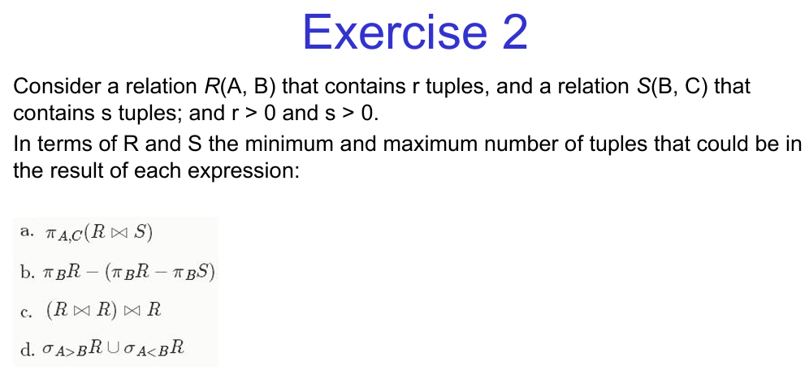
Two more similars:
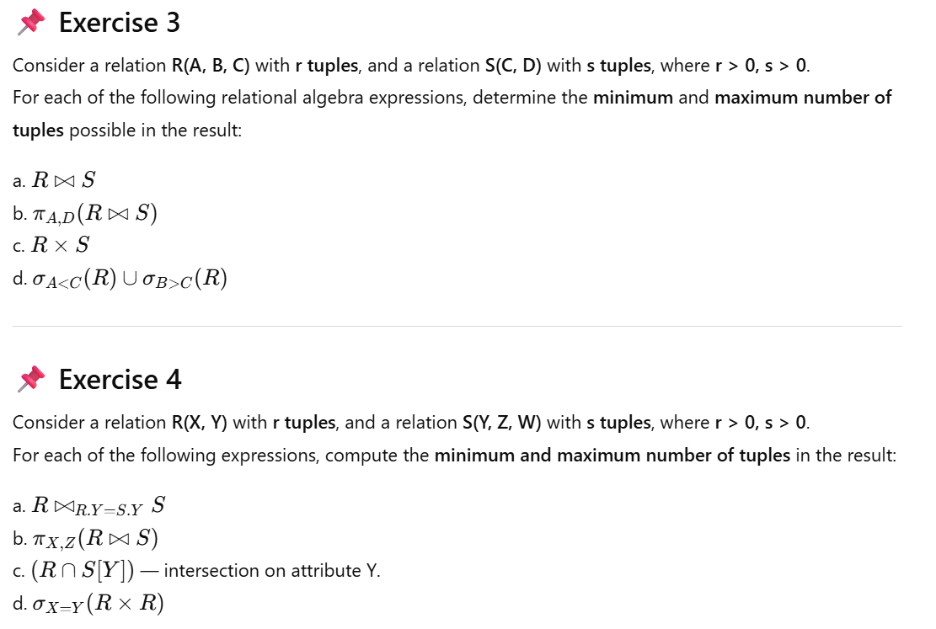
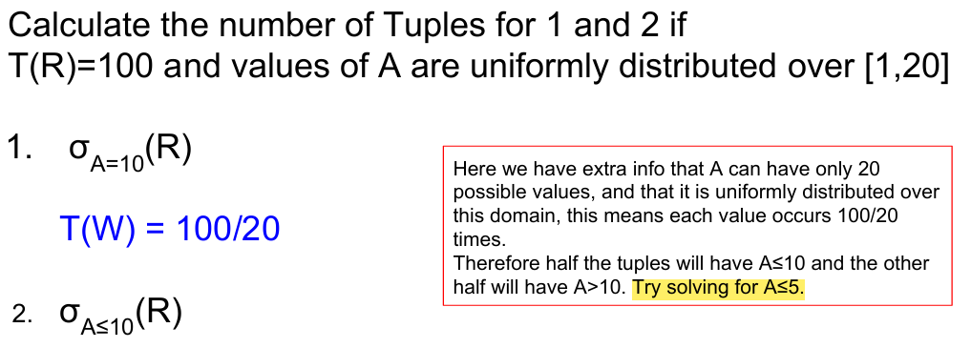
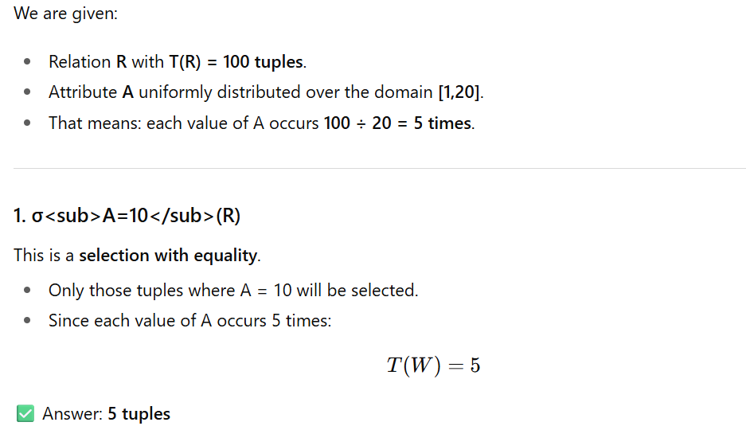
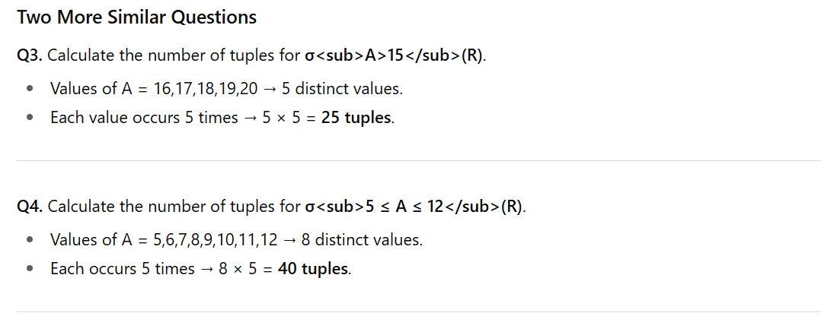

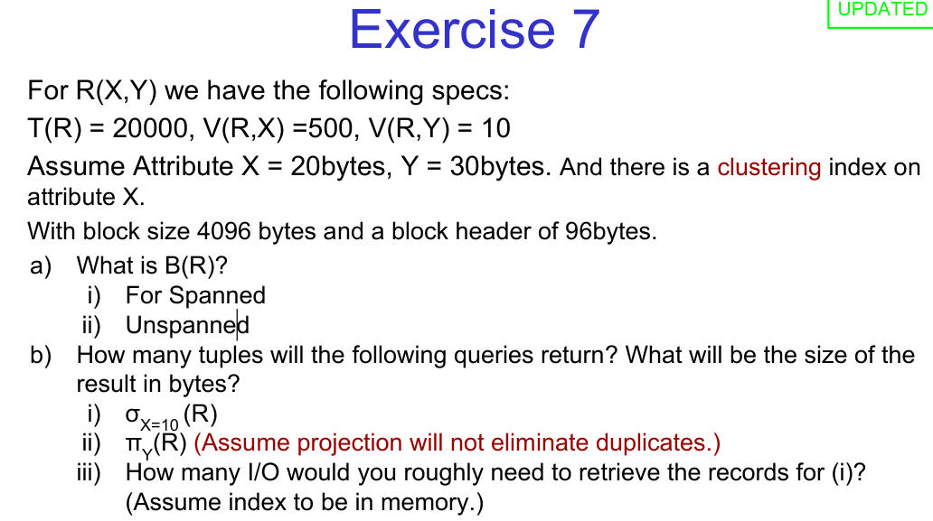
Spanned vs. Unspanned in the context of file organization and record storage in DBMS.

🔹 1. Spanned Records
- A record is spanned if it is allowed to span across multiple blocks (pages).
- If a record is larger than the size of one block, part of it is stored in one block, and the remaining part continues in the next block.
- A pointer or continuation marker is maintained to link the fragments.
Pros
- Efficient space utilization (no wasted space if record > block size).
- Can store very large records.
Cons
- Accessing a single record may require reading multiple blocks → slower retrieval.
- Extra overhead of managing pointers/links.
Example:
Block size = 1KB, record size = 1.5KB → record is stored as 1KB in one block + 0.5KB in next block.

🔹 2. Unspanned Records
- A record is unspanned if it is stored entirely within a single block.
- A record cannot cross block boundaries.
Pros
- Faster retrieval (one block read per record).
- Easier record management (no need for continuation pointers).
Cons
- Wasted space (if block size is smaller than record size, record can’t be stored at all).
- Some block space may remain unused (if record doesn’t perfectly fit).
Example:
Block size = 1KB, record size = 1.5KB → record cannot be stored at all in unspanned organization.

🔑 Key Difference Table
Feature | Spanned | Unspanned
Record across blocks | Allowed | Not allowed
Storage efficiency | High | Lower
Retrieval speed | Slower (may need multiple blocks) | Faster (one block only)
Complexity | Higher (needs pointers) | Simpler
Large records | Supported | Not supported if > block size

👉 In practice:
- Spanned is used when record sizes can be very large (like multimedia, documents).
- Unspanned is used for fixed-length, small records (like employee IDs, student info).

more questions in the same style as Exercises 7–9 from your notes (with specs, size estimation, projections, selections, I/O costs, etc.). Like q. 7 to 10 in amena note:

🔹 New Practice Questions

Exercise 10
For relation R(P,Q), we have the following specs:
- T(R) = 50,000
- V(R,P) = 1,000
- V(R,Q) = 100
- Attribute P = 20 bytes, Q = 40 bytes
- Block size = 8192 bytes, block header = 128 bytes
a) Compute B(R) for:
i) Spanned
ii) Unspanned
b) For the following queries, estimate number of tuples and result size (bytes):
i) σP=25(R)
ii) σQ≤50(R)
iii) πQ(R) (assume duplicates are not eliminated)
c) If there is a clustering index on P, how many I/Os are required for query (i)?

Exercise 11
For relation S(M,N,O), we have:
- T(S) = 12,000
- V(S,M) = 60
- V(S,N) = 200
- V(S,O) = 400
Estimate the number of tuples and value sets for results of:
a) σM=10(S)
b) σN<50(S) (assume uniform distribution)
c) πM,O(S) (assume projection eliminates duplicates)

Exercise 12
For relation T(U,V),
- T(T) = 100,000,
- V(T,U) = 5000,
- V(T,V) = 50.
Assume block size = 4096 bytes, header = 96 bytes, tuple size = 60 bytes.
a) Compute B(T) for spanned and unspanned storage.
b) Estimate number of tuples for:
i) σU=20(T)
ii) σV≤25(T)
iii) πV(T) (with duplicates eliminated)
c) If attribute U has a secondary non-clustering index, how many I/Os would you expect for (i)?

Exercise 13
For relation R(A,B) and S(B,C):
- T(R) = 2,000, V(R,B) = 100
- T(S) = 5,000, V(S,B) = 200, V(S,C) = 50
a) Estimate T(R ⋈ S)
b) Estimate T(R ⋈ σC=10(S))
c) Estimate T(σB=50(R) ⋈ S)

Exercise 14
Relation U(X,Y),
- T(U) = 30,000
- V(U,X) = 3000
- V(U,Y) = 50
- B(U) = 400
Indexes:
- Primary dense index on X (clustering)
- Secondary index on Y (non-clustering)
Estimate I/O cost for:
a) σX=20(U)
b) σY=10(U)
c) σY=10 AND X=15(U)

These mirror the style of the original exercises:
- Storage calculations (spanned vs. unspanned)
- Tuple estimates (using V and T)
- Projection vs. selection differences
- I/O costs with clustering vs. non-clustering indexes
- Joins combined with selections

👉 Do you want me to also write out full worked solutions for these (like in your notes), or would you prefer to try solving them first and then check answers?
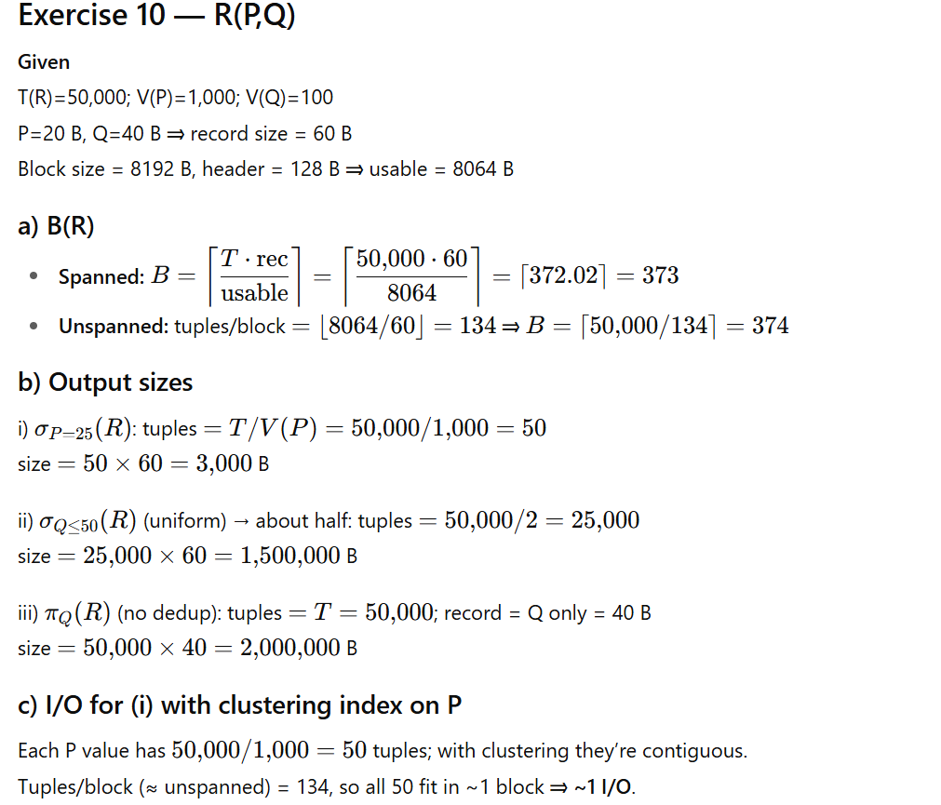
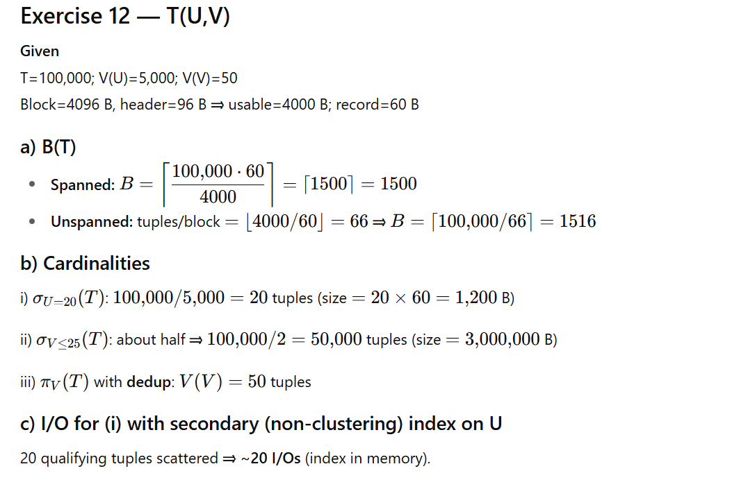
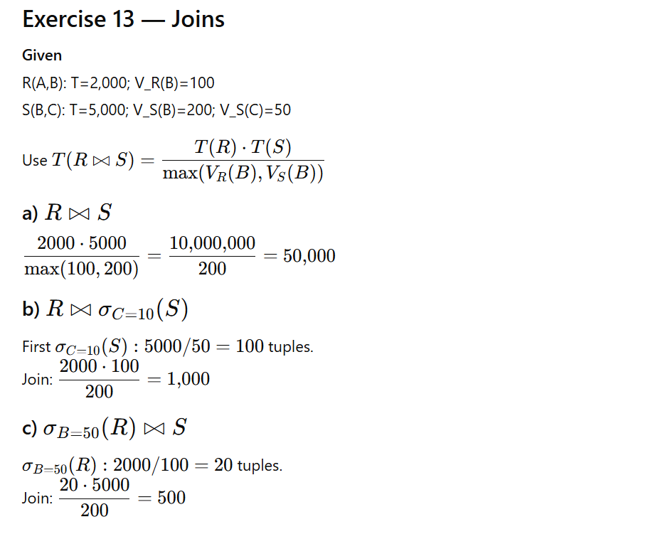

- Teaching the concepts behind Exercises 7–14 (so you know why we calculate things like tuple counts, block counts, and I/Os).
- A focused exam cheat sheet — formulas, rules, and shortcuts in one page.

🧑‍🏫 Concepts Behind the Exercises
These exercises combine 3 major ideas:

1. Storage & Blocks (Spanned vs Unspanned)
👉 Why important? Query cost depends on how many disk blocks must be read.
- Tuple Size = sum of attribute sizes.
- Usable Block Space = BlockSize – HeaderSize.
- Spanned Storage: Tuples can be split across blocks.
Tuples/Block=UsableRecordSize\text{Tuples/Block} = \dfrac{\text{Usable}}{\text{RecordSize}}
- Unspanned Storage: Tuples must fit fully in one block.
Tuples/Block=⌊UsableRecordSize⌋\text{Tuples/Block} = \left\lfloor \dfrac{\text{Usable}}{\text{RecordSize}} \right\rfloor
- #Blocks Needed:
B(R)=⌈T(R)Tuples/Block⌉B(R) = \left\lceil \dfrac{T(R)}{\text{Tuples/Block}} \right\rceil
🔑 Takeaway: Spanned saves space, Unspanned wastes a bit.

2. Selection & Projection Estimates

Selection (σ)
- Equality:
T(W)=T(R)V(R,A)T(W) = \dfrac{T(R)}{V(R,A)}
- Inequality (≤, ≥, <, >) with uniform distribution:
T(W)≈T(R)2T(W) \approx \dfrac{T(R)}{2}

Projection (π)
- Without duplicate removal:
T(W)=T(R)T(W) = T(R)
- With duplicates removed:
T(W)=V(R,A)T(W) = V(R,A)
🔑 Takeaway: Selections shrink rows, projections shrink columns.

3. Joins
👉 Joins combine two relations on a common attribute.
Formula (containment assumption):
T(R⋈S)=T(R)⋅T(S)max⁡(V(R,A),V(S,A))T(R \bowtie S) = \dfrac{T(R)\cdot T(S)}{\max(V(R,A),V(S,A))}
- If no overlap: result = 0.
- If complete overlap: result = T(R)⋅T(S)T(R) \cdot T(S).
🔑 Takeaway: The higher distinct count dominates.

4. Indexing and I/O Cost
👉 Goal: estimate how many disk block reads (I/Os) are needed.
- Clustering Index: records with same key are stored together → usually 1 block I/O.
- Non-Clustering Index: records scattered → about 1 I/O per tuple.
Example:
- σA=10 with clustering index → all 40 matching records in one block → 1 I/O.
- Same with non-clustering index → 40 records in 40 blocks → 40 I/Os.
🔑 Takeaway: Clustering saves I/Os, non-clustering costs more.

📌 Exam Cheat Sheet (One Page)

🔹 Key Notation
- T(R) = tuples in relation R
- V(R,A) = distinct values of attribute A in R
- S(R) = tuple size (bytes)
- B(R) = # of blocks

🔹 Block Calculations
- Usable Block Space = BlockSize – HeaderSize
- Spanned: Tuples/Block = Usable / RecordSize
- Unspanned: Tuples/Block = floor(Usable / RecordSize)
- Blocks Needed: B(R) = ceil(T(R) / TuplesPerBlock)

🔹 Selection (σ)
- Equality: T(W) = T(R)/V(R,A)
- Inequality (≤, ≥): T(W) ≈ T(R)/2 (uniform)
- Range [a…b]: fraction × T(R)

🔹 Projection (π)
- Without duplicate removal: T(W) = T(R)
- With duplicates removed: T(W) = V(R,A)

🔹 Joins (⋈)
- Formula:
T(R⋈S)=T(R)⋅T(S)max⁡(V(R,A),V(S,A))T(R \bowtie S) = \dfrac{T(R)\cdot T(S)}{\max(V(R,A),V(S,A))}
- Cartesian Product (×): T(R) × T(S)

🔹 Set Operations
- Union: R ∪ S = all tuples (no dups)
- Intersection: R ∩ S = common tuples
- Difference: R – S = in R but not S

🔹 Index I/O Rules
- Clustering index: all tuples with same value likely in 1 block → ~1 I/O.
- Non-clustering index: 1 I/O per tuple.

🔹 Quick Examples
- σA=5(R) → T(R)/V(R,A)
- σA≤10(R) → T(R)/2 (uniform)
- πA(R) with DISTINCT → V(R,A)
- Join → (T(R) × T(S)) / max(V(R,A),V(S,A))
- Block count (Unspanned) → floor((Block–Header)/Record)

✅ With this, you can solve any of the Exercises 7–14.

Perfect 🚀 — let’s build a mini mock exam that feels like a real test.
It’ll have a mix of short, medium, and long questions (like what you’d see in a DBMS exam). I’ll also include a separate answer key so you can test yourself first.

🎓 Mock Exam — Query Processing & Relational Algebra

Part A: Short Answer (2–3 marks each)
Q1.
Relation R(A,B) has T(R)=10,000, V(R,A)=100.
Estimate the number of tuples in σA=25(R).

Q2.
Block size = 4096 bytes, header = 96 bytes.
Tuple size = 80 bytes.
How many tuples fit per block for:
a) Spanned
b) Unspanned

Q3.
R(A) = {1,2,3,4}, S(A) = {3,4,5,6}.
Find:
a) R ∪ S
b) R ∩ S
c) R – S

Part B: Medium Answer (5–6 marks each)
Q4.
Relation R(X,Y) has T(R)=20,000, V(R,X)=500, V(R,Y)=10.
Tuple size = 50 bytes (X=20, Y=30).
Block size = 4096 bytes, header = 96 bytes.
There is a clustering index on X.
a) Compute B(R) for spanned and unspanned storage.
b) Estimate tuples and result size (bytes) for σX=10(R).
c) How many I/Os would you expect for this selection?

Q5.
R(A,B) has T(R)=2000, V(R,B)=40.
S(B,C) has T(S)=500, V(S,B)=20, V(S,C)=10.
Estimate the result size for:
a) R ⋈ S
b) R ⋈ σC=5(S)
c) σB=10(R) ⋈ S

Part C: Long Answer (8–10 marks each)
Q6.
Relation T(U,V),
- T(T) = 100,000
- V(T,U) = 5000, V(T,V) = 50
- Tuple size = 60 bytes
- Block size = 4096 bytes, header = 96 bytes
a) Compute B(T) for spanned and unspanned.
b) Estimate tuple counts for:
i) σU=20(T)
ii) σV≤25(T)
iii) πV(T) (assume duplicates eliminated).
c) If attribute U has a secondary non-clustering index, how many I/Os would query (i) require?

✅ Answer Key

Q1.
Tuples = T(R)/V(R,A) = 10000/100 = 100.

Q2.
Usable = 4096–96=4000 bytes.
- Spanned = 4000/80 = 50
- Unspanned = floor(4000/80)=50 (same here).

Q3.
a) R ∪ S = {1,2,3,4,5,6}
b) R ∩ S = {3,4}
c) R – S = {1,2}

Q4.
a) Tuple size=50; Usable=4000;
- Spanned=4000/50=80 → B=20000/80=250
- Unspanned=floor(4000/50)=80 → same = 250
b) σX=10(R) → 20000/500=40 tuples
Size=40×50=2000 bytes
c) With clustering, all 40 tuples likely in one block → ~1 I/O

Q5.
a) (2000×500)/max(40,20)=1,000,000/40=25,000
b) σC=5(S)=500/10=50 → (2000×50)/40=100,000/40=2500
c) σB=10(R)=2000/40=50 → (50×500)/20=25,000/20=1250

Q6.
a) Record=60; Usable=4000
- Spanned=4000/60=66.67 → B=100000/66.67≈1500
- Unspanned=floor(4000/60)=66 → B=100000/66≈1516
b)
i) σU=20(T) → 100000/5000=20 tuples
ii) σV≤25(T) → 100000/2=50,000 tuples
iii) πV(T) with DISTINCT → V(V)=50
c) For i) → 20 tuples scattered with secondary index → ≈20 I/Os

✅ This mock covers blocks, selections, projections, joins, and I/Os — exactly what shows up in exams.

